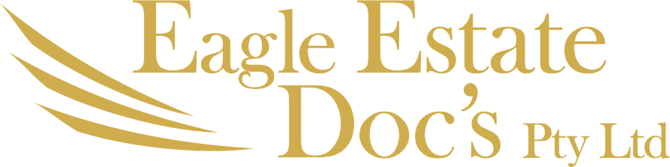
Trading as
AUDIT YOUR SMSF
ABN: 22 637 446 407
SELF MANAGED SUPER FUND SPECIALISTS
PO Box 164, Eagle Heights, Qld 4271 Physical address: 36 Southport Avenue, Tamborine Mountain, Qld 4272
Email:audits@eagleestatedocs.com.au – Ph: 0418936395

Date:

Fund Name:

Dear
Re:

Letter of Engagement

Reference is made to my engagement in respect to the audit of your superannuation fund for the purposes of the Superannuation Industry (Supervisory) Act.

As discussed, I would appreciate the opportunity to complete the audits. The purpose of this letter is to confirm my responsibilities and the basis of our relationship.

My primary aim is to assist my clients maximize their financial position. I operate within the ethical guidelines of The National Institute of Accountants. Our responsibilities would be as follows:

- Compliance audit and review of your superannuation fund.

- Preparation of Audit Report and management letter in respect to the audit.

As discussed, the audit will involve review of the financial statements and tax returns and all sources documents. I will discuss the timing and information required over the proceeding months, however, the majority of my work will be completed at the end of the audit period.

In respect to our fees for our work, I confirm that the audit fee will not exceed the amount negotiated with your SMSF administrator and includes GST an all outlays in respect of the audit. This amount is payable within 7 days on completion of the audit reviews, and is conditional on payment within these terms. I do not charge for minor telephone calls and discussions. All work is completed in my office.

To enable me fulfil my responsibilities in a timely and cost effective basis, I would expect your full co-operation with the following:

- Providing us with the necessary information on a timely basis, so that I may efficiently complete the required task.

- Allowing me sufficient time to complete my work prior to an imminent deadline.

Responsibilities

In conducting this engagement, information acquired by us in the course of the engagement is subject to strict confidentiality requirements. The information will not be disclosed by us to other parties except as required or allowed by law, or with your express consent.

We wish to draw your attention to our firm’s system of quality control which has been established and maintained in accordance with the relevant APESB standard. As a result, our files may be subject to review as part of the control review program of The National Institute of Accountants which monitors compliance with professional standards by its members. We advise you that by accepting our engagement you acknowledge that, if requested, our files relating to this engagement will be made available under this program. Should this occur, we will advise you.

You are required to arrange for reasonable access by us to relevant individuals and documents, and shall be responsible for both the completeness and accuracy of the information supplied to us.

Trustees Responsibilities

It is the Trustees responsibility to provide detail of the value of any unlisted investment. We take no responsibility for the value or financial viability of an unlisted investment.

Termination of Services

On termination of this company as auditor should any on-going auditor require ethical letters or copies of reports or transfers a fee of $100 is payable by the fund prior to any transfer of reports or files to reflect time spent on this request.

Limitation of Liability

As you aware each investment has multiple risks, including loss of capital. In conducting our audit, we will not be checking the liquidity of the Fund’s assets, the nature of the class of investments, nor their suitability to the Fund’s investment strategy. If any asset’s capital is lost, due to any reason, we will not be responsible for any damages under section 12GF of Australian Securities and Investments Commission Act 2001.
You are responsible for investing the Funds’ assets and you should take full care of those investments. However, as an auditor, it is our duty of care to inform you, if in our opinion, we notice any investments are not recoverable. Please note many investments are complex in nature and we are not trained as SMSF auditors to analyse each investment; hence you should not entirely rely in our opinion.

In conduct of our audit, we are required to form an opinion and report to you if the Fund is making or likely to make an economic loss or the Fund’s assets are damaged or likely to get damaged due to conduct of any other person who you rely on for investment decisions or appoint as custodians or investments manager.

We are appointed to audit the Fund’s financial report and not to audit entities where this Fund invests such custodian services, unrelated trusts, companies or other entities.

Our liability is limited by a scheme approved under Professional Standards Legislation. Further information on the scheme is available from the Professional Standards Councils website www.professionstandardscoucil.gov.au

Ownership of Documents

All original documents obtained from you arising from the engagement shall remain your property. However, we reserve the right to make a reasonable number of copies of the original documents for our records.

Our engagement will result in the production of an audit report. Ownership of this document will vest in you. All other documents produced by us in respect to this engagement will remain the property of the firm.

The firm has a policy of exploring a legal right lien over any client documents in possession in the event of a dispute. The firm has also established dispute resolution processes.

I believe that our clients receive the greatest benefit of my knowledge and experience from an on-going and open relationship. Therefore I am always available to discuss any audit or accounting issue. We do no charge for telephone discussions.

If these arrangements are acceptable, please sign and return this letter. I will liaise with your appointed SMSF administrator in respect to the timing of the audit.

If you have any queries or wish to discuss this matter further, please do not hesitate to give me a call.

Yours faithfully
Eagle Super Audit Brisbane

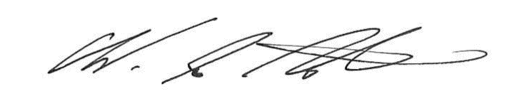
………………………………. ……………………………….………………………………………..
Wendy le Noble Trustees
Accountant (IPA)(SPAA)
ASIC SMSF Auditor:100169051

